Assignment#4
NOTE: Understanding the question is part of assignment. Total= 10 Marks

Problem Statement #1
(5 marks)
Write a program that uses the MMX instruction to sum all even numbers in an unsigned char array of size 8 and store its result in a variable. The program should use an inline assembly to execute MMX instructions, while the array is declared and initialized in C++.
SOLUTION:
#include <iostream>
using namespace std;

int main() {
unsigned char data[8] = { 10, 3, 4, 7, 8, 12, 1, 6 };
unsigned char lsb[8] = { 1, 1, 1, 1, 1, 1, 1, 1 };
unsigned char Even_Nums[8] = { 0 };
unsigned int SUM = 0;

__asm {
MOVQ MM0, [data]
MOVQ MM1, [data]
MOVQ MM2, [lsb]

PAND MM1, MM2 // Result: 1 if odd, 0 if even

PXOR MM2, MM2 // MM2 = 0
PCMPEQB MM1, MM2 // Compare (data & 1) == 0.
// Result: 0xFF if even, 0x00 if odd.

PAND MM0, MM1 // Masking -> Odd numbers become 0, Evens stay the same.

MOVQ[Even_Nums], MM0
EMMS
}

unsigned int temp = 0;
cout << "Even Numbers: ";
for (int i = 0; i < 8; i++) {
temp = Even_Nums[i];
if (temp != 0) {
cout << temp << " ";
}
}cout << endl;

for (int i = 0; i < 8; i++) {
SUM += Even_Nums[i];
}

cout << "Sum: " << SUM << endl;

return 0;
}

OUTPUT:
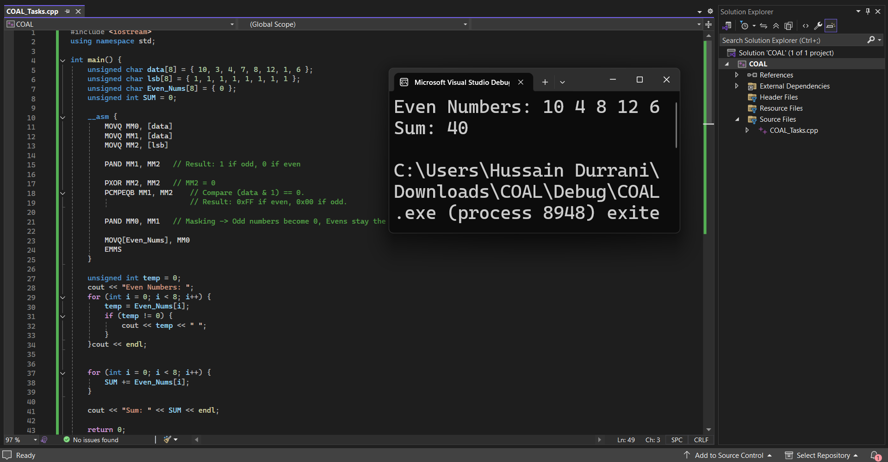
Problem Statement #2
(5 marks)
Write a C++ program that uses inline assembly language to sort an integer array of size 10 in ascending order. The array should be declared and initialized in C++. The sorting logic must be implemented using inline assembly instructions. The program should compare adjacent elements of the array and perform swapping where necessary to arrange the elements in ascending order. After completing the sorting process, the program should display the sorted array using C++ output statements.
SOLUTION:
#include <iostream>
using namespace std;

int main() {
int arr[10] = { 25, 10, 5, 30, 15, 2, 8, 12, 20, 3 };
int n = 10;

cout << "Array before Sorting: ";
for (int i = 0; i < 10; i++) {
cout << arr[i] << " ";
}
cout << "\n\n";

__asm {
mov ecx, n
outer_loop :
dec ecx
jz done

mov esi, 0
mov edx, ecx // Inner loop counter

inner_loop :
mov eax, [arr + esi * 4] // eax = arr[j]
mov ebx, [arr + esi * 4 + 4] // ebx = arr[j+1]

cmp eax, ebx // Compare arr[j] & arr[j+1]
jle skip_swap // If arr[j] <= arr[j+1], no swap needed

// Swap
mov[arr + esi * 4], ebx
mov[arr + esi * 4 + 4], eax

skip_swap :
inc esi // j++
dec edx // Decrement inner counter
jnz inner_loop // Repeat inner loop if edx != 0

jmp outer_loop // Repeat outer loop
done :
EMMS
}

cout << "Sorted Array: ";
for (int i = 0; i < 10; i++) {
cout << arr[i] << " ";
}
cout << endl;

return 0;
}
OUTPUT:
